Protouch MPT User Manual

USB 253x

USB 3613

USB 3813

USB 4604

USB 4624



Version: 1.1

Date: January 23, 2014

THE INFORMATION CONTAINED HEREIN IS CONFIDENTIAL AND PROPRIETARY TO SMSC, SHALL BE USED SOLELY IN ACCORDANCE WITH THE AGREEMENT PURSUANT TO WHICH IT IS PROVIDED, AND SHALL NOT BE REPRODUCED OR DISCLOSED TO OTHERS WITHOUT THE PRIOR WRITTEN CONSENT OF SMSC. ALTHOUGH THE INFORMATION IS BELIEVED TO BE ACCURATE, NO RESPONSIBILITY IS ASSUMED FOR INACCURACIES. SMSC RESERVES THE RIGHT TO MAKE CHANGES TO THIS DOCUMENT AND TO SPECIFICATIONS AND PRODUCT DESCRIPTIONS AT ANY TIME WITHOUT NOTICE. NEITHER THE PROVISION OF THIS INFORMATION NOR THE SALE OF THE DESCRIBED SEMICONDUCTOR DEVICES CONVEYS ANY LICENSES UNDER ANY PATENT RIGHTS OR OTHER INTELLECTUAL PROPERTY RIGHTS OF SMSC OR OTHERS. THE PRODUCT MAY CONTAIN DESIGN DEFECTS OR ERRORS KNOWN AS ANOMALIES, INCLUDING BUT NOT NECESSARILY LIMITED TO ANY WHICH MAY BE IDENTIFIED IN THIS DOCUMENT, WHICH MAY CAUSE THE PRODUCT TO DEVIATE FROM PUBLISHED SPECIFICATIONS. SMSC PRODUCTS ARE NOT DESIGNED, INTENDED, AUTHORIZED OR WARRANTED FOR USE IN ANY LIFE SUPPORT OR OTHER APPLICATION WHERE PRODUCT FAILURE COULD CAUSE OR CONTRIBUTE TO PERSONAL INJURY OR SEVERE PROPERTY DAMAGE.

The customer is the best judge of the value and importance of the data held on the SMSC hardware or software and should institute and operate all necessary backup procedures to ensure that data integrity can be maintained in the event of loss of data for any reason. In addition, the customer may wish to consider taking out an insurance policy or other financial cover for loss or damage, which may arise from loss of data. SMSC cannot be responsible for loss of data.



4th Floor, SP Infocity

#40, MGR Salai, Perungudi

Chennai - 600 096

India

Telephone: +914443459200

**Corporate Headquarters**  
80 Arkay Drive  
Hauppauge, NY 11788  
Telephone: 1-631-435-6000

**Change Information**

|  |  |  |  |
| --- | --- | --- | --- |
| Date | Version | Author | Description of changes |
| April 17, 2013 | 1.0 | MPT Tool Team | Initial release |
| January 23, 2014 | 1.1 | MPT Tool Team |  |
|  |  |  |  |

Table of Contents

1 Introduction: 5

1.1 Functional Tabs: 5

1.2 Overview of Steps Required: 6

1.2.1 Programing/Verification of devices: 6

1.2.2 Creating/Editing binary configuration: 6

2 Topology Configuration Page: 7

2.1 Topology Menu: 7

2.2 Configuration Steps: 7

2.3 Configuration Settings: 8

2.3.1 Part type/number 8

2.3.2 Memory Type 9

2.3.3 Operation 9

2.3.4 Choose Binary Configuration File: 10

2.4 Save the Topology: 11

2.5 Node Configuration State Colour Description: 11

2.6 Advanced Settings: 12

3 Execution Page: 12

3.1 Execute Once: 13

3.2 Automated Execution: 13

3.3 Execution State Colour Description: 13

3.4 Device safe removal symbol: 14

4 Configuration Editor Page: 14

4.1 Create Configuration File: 14

4.2 Load Configuration File: 17

5 Configurable items for USB253x/3613/3813/4604/4624: 20

6 Installation and System Requirement 21

6.1 System Requirement: 21

6.2 Installation Steps: 21

6.3 Troubleshoot: 21

# Introduction:

The purpose of this manual is to detail the functionality of the Protouch MPT programming tool for configuring the SMSC USB253x/USB3613/USB3813//USB4604/ USB4624 family of USB controller hubs. The Protouch MPT programming tool provides the ability to configure the USB tree topology with node specific configuration settings, program/verify configured devices, and create/edit the binary configuration file. The Protouch MPT programming tool is designed to be used on the manufacturing line as well as during initial prototyping.

***Note:*** *For details on system requirements and installation procedures, refer to Section 6, "System Requirements, Installation & Troubleshooting," on page 17.*

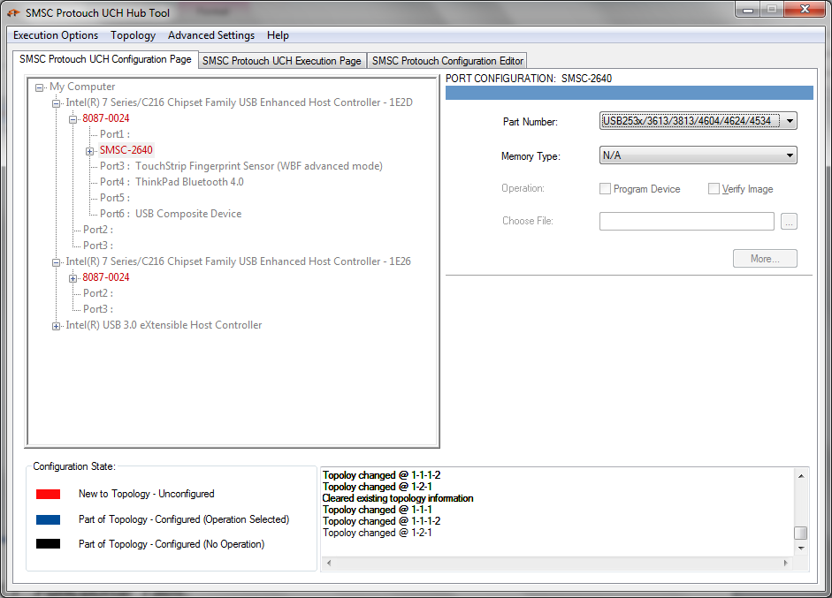

Figure 1.1 Protouch UCH Hub Tool

## Functional Tabs:

1. *Topology Configuration Page* – tree topology and node specific settings have to be configured and saved.
2. *Execution Page* – program and/or verify the configured devices and display the status messages
3. *Configuration Editor Page* – create/edit the binary configuration file

## Overview of Steps Required:

### Programing/Verification of devices:

1. Start the tool and go to topology configuration tab

b) Connect all Hub devices to set up the tree topology

c) Select each node (hub) and configure for operation

d) Save the topology

e) Switch to execution page

f) Select execution option and click “Start” button

### Creating/Editing binary configuration:

1. Start the tool and go to configuration editor tab
2. Create/edit the configuration file

# Topology Configuration Page:

During the Initial start of the tool, topology and node settings have to be configured and saved (tcf format file).

On subsequent start of the tool, list of connected devices that matches with the last saved topology configuration (tcf file) will be displayed as configured devices while new devices will still be shown as un-configured devices.



Figure 2.1 Protouch UCH Configuration Page

## Topology Menu:

New – Clears the exiting topology and node settings

Save – Save the topology ones all nodes have been configured

Load – load the topology configuration settings for the current tree topology

## Configuration Steps:

1. Connect hub device in tree node which needs to be configured
2. Only hub connected nodes can be configured
3. Set configuration settings for the selected node
4. Save the topology once all nodes are configured

## Configuration Settings:

### Part type/number

Part type displays following options

1. USB553x
2. USB253x/3613/3813/4604/4624
3. Not Recognized

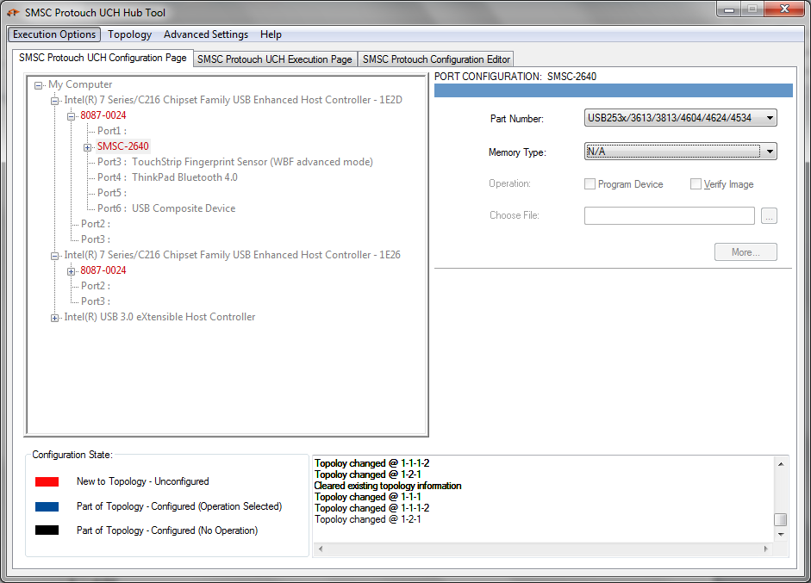

Figure 2.2 Protouch UCH Configuration Page Part Number Selection

* **USB253x/3613/3813/4604/4624**

To configure the node for any operation, thereby connecting any “USB253x/3613/3813/4604/4624” part type device in the node will execute the configured operation.

* **Not Recognized**

If not intend to program the hub device

### Memory Type

The following Memory Type options will be displayed for

***USB253x/3613/3813/4604/4624*** part type,

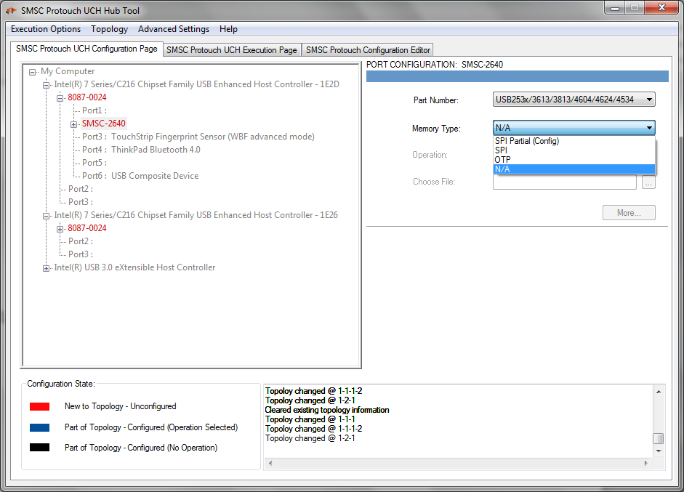

Figure 2.3 Configuration Page Memory Type Selections

1. SPI
2. OTP
3. N/A
   1. Selecting N/A means the user not intend to configure the device for any operation.
   2. Selecting any other option enables the other controls

### Operation

User must select any one of the following operation or both to complete configuring the node.

Selecting an operation will enable the other controls

1. Program Device
2. Verify Image

Selecting any of these options enables “Choose File” option

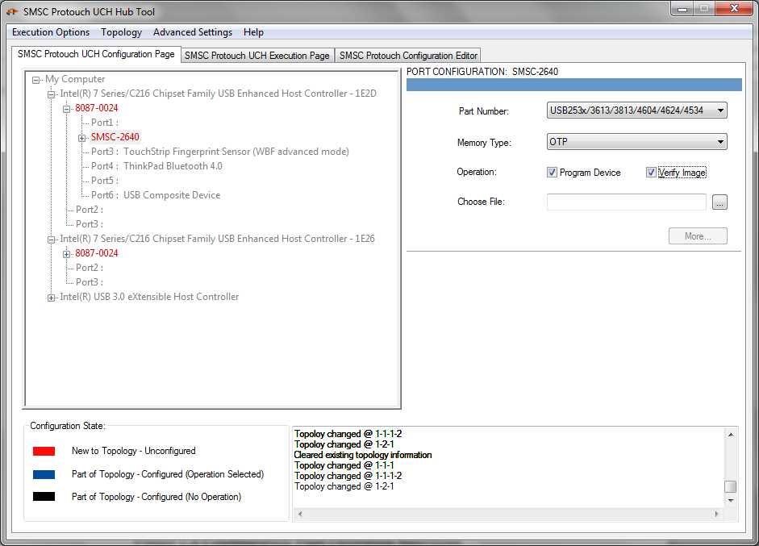

Figure 2.4 Configuration Page Operation Selections

### Choose Binary Configuration File:

1. Click the “**…**” Button to display the file “Open” dialog
2. “Open” dialog choose the corresponding file which needs to be programmed/verified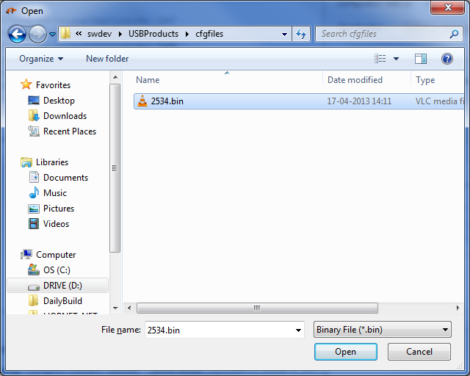

## Save the Topology:

Once all the nodes are configured, save the topology in a file

1. Click “Topology” menu -> “Save”
2. Opens “Save As” dialog
3. Specify the file name and save the topology

## Node Configuration State Colour Description:

Red – New to the topology and the node is un-configured

Blue – Node saved as Part of the topology and configured for operation

Black – Node saved as Part of the topology but not for any operation

(Part type and/or Memory type option for the node is N/A)

## Advanced Settings:

Advanced settings menu provides options to

1. Disable UUID - disable UUID detection (only USB553x)
2. Enable Debug options - shows available debug options

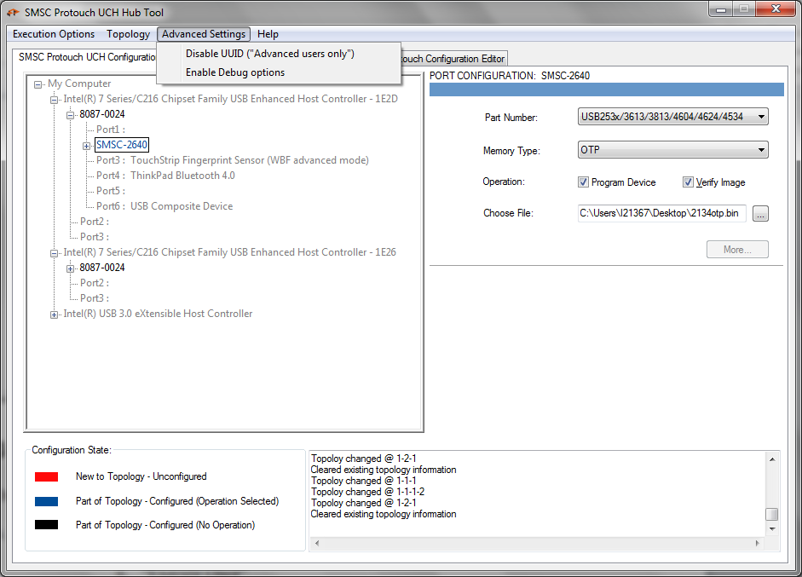

# Execution Page:

Once the topology configuration has been done, switch to execution page

* 1. It has two radio buttons two choose execution operation
     1. “Automated execution”
     2. “Execute Once”
  2. Once chosen the execution option click “Start” Button (changes to Stop while device programming is in progress) to start the operation
  3. Topology UI tree will show the progress of the operation in color codes

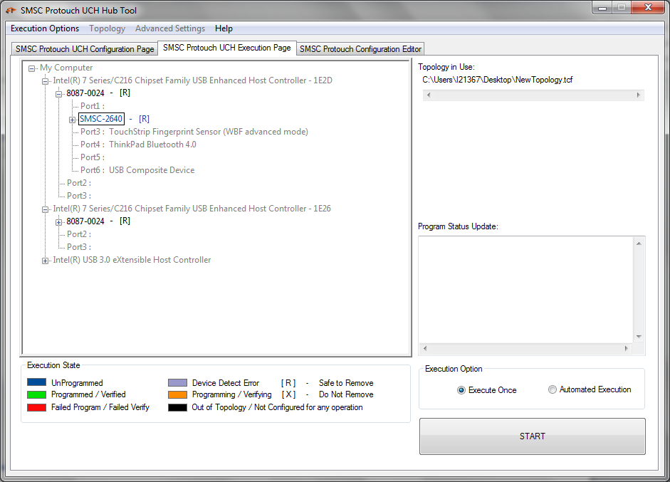

Once the “Start” button is selected, the execution will be started for all the configured devices and the “Stop” button will appear

## Execute Once:

In this option once all the connected and configured devices are done with its operation, the execution will be automatically stopped and the “Start” button will appear again.

User has to replace the entire device in the topology and connect the new one to be programmed as per the configured topology and start the operation again

## Automated Execution:

This mode is same as “Execute Once” mode except that in this mode the “execution engine” will not stop. Once a device has been programmed, a new device can be connected to replace the programmed device. New device will be automatically detected and will be executed for operation as per its configuration.

## Execution State Colour Description:

The execution state information at the bottom of the UI tree shows the operation status of the node

Blue – Device configured but not yet programmed

Green – Programmed and/or verified successfully

Red – Failed programming and/or verification

Violet – Device detection error

Orange – Programming and/or verification is in progress

Black – Device not configured for any operation / Device is out of topology

## Device safe removal symbol:

[ X ] – Do not remove the device when it shows this symbol, even if it has been successfully executed its operation

[ R ] – Remove the device only after it show this safe to remove symbol

# Configuration Editor Page:

Configuration editor page provides facility to prepare configuration file which can be used to override the default configuration of hub device. Application maintains master XML file which is used to populate GUI with default values.

Configuration editor page provides two features to user

1. New configuration file creation (Create Configuration File)
2. Load existing configuration file (Load Configuration File)

## Create Configuration File:

There are several configuration fields exposed by the firmware which can be configured using configuration file. Configuration file can be created by configuration editor page. When configuration file selected by user, application loads the page using master XML file. Here is snapshot of configuration page.

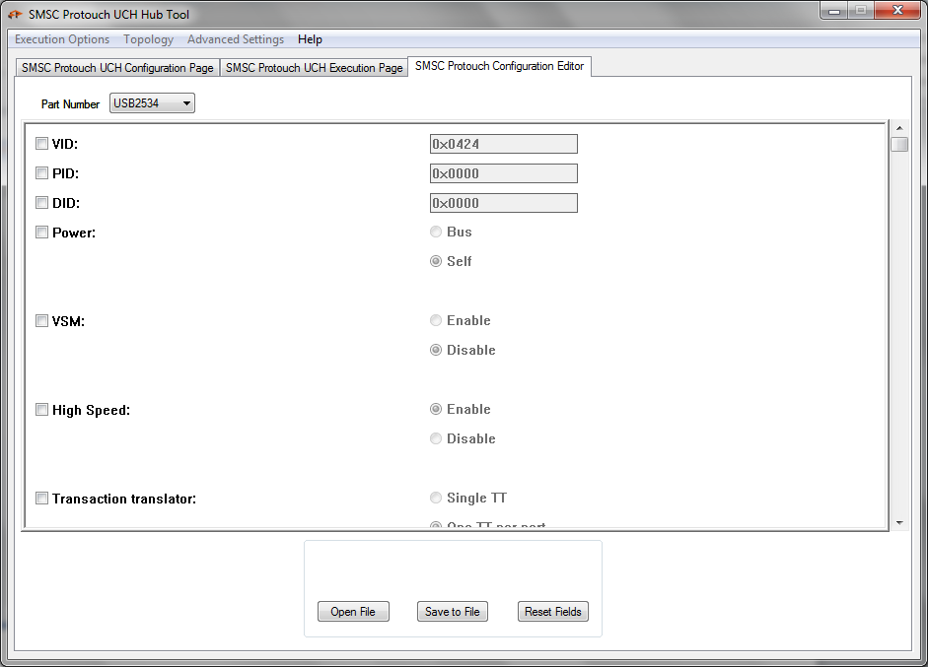

Consider the case if user chooses to program VID, PID and DID. User should check the check box against VID, PID and DID field. Here is snapshot

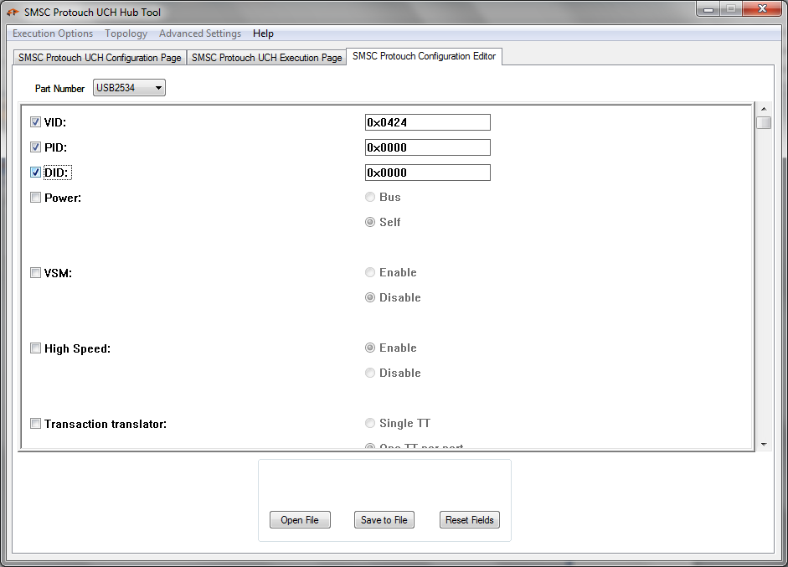

Now user should update the values in edit box with desired values. Here is snapshot

After selecting and updating the required fields and values user should press “Save to File” button. Application will pop the path selection dialog.

Application will generate configuration file at selected path.

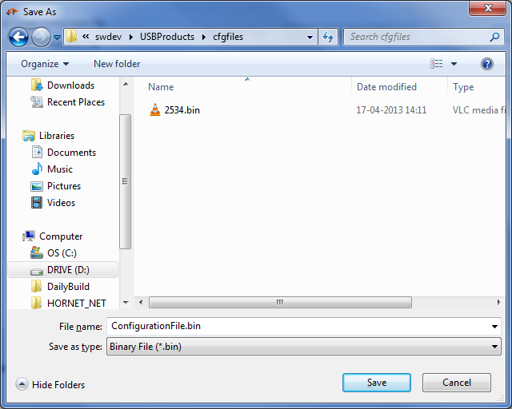

## Load Configuration File:

Configuration editor page provides facility to view existing configuration files. For viewing settings provided in existing configuration file user should select Part type and then “Open File” button.

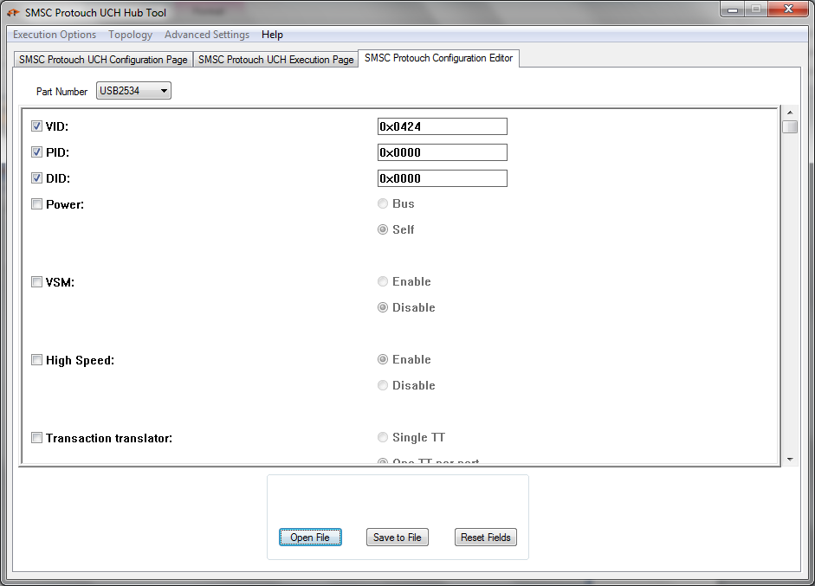

On clicking “Open File” application will pop up file selection dialogue user should choose the desired file.

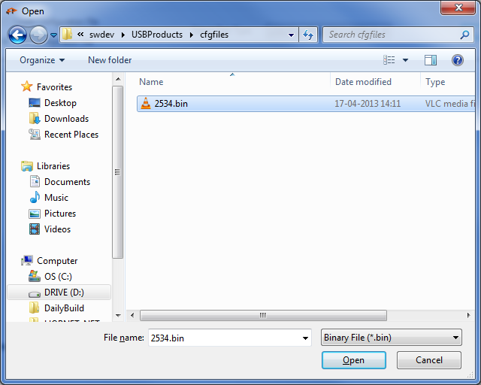

Application will verify the binary configuration file and will load the configuration settings from the file.

# Configurable items for USB253x/3613/3813/4604/4624:

* USB VID, PID and device ID of the hub – Vendor ID, Product ID and Device ID
* Self/bus power – Self / Bus powered hub
* VSM for hub enable / Disable – Enable / Disable VSM
* HS Disable – High Speed disable
* MTT enable/disable – Enables / Disables MTT
* EOP enable/disable – Enable / Disable EOP
* Overcurrent sensing type (ganged / port-by-port) selection – Over current sensing type, can be ganged or port-by-port
* Port power control type (ganged / port-by-port) selection – Port power control type, can be ganged or port-by-port
* Dynamic power enable (automatically switching to bus power operation when self-power is removed) – Enable / Disable dynamic power switching
* OC_Timer – Over Current sense time
* COMPOUND – Compound hub
* Hub resume inhibit enable/disable – Enables / Disables Hub resume inhibit
* Port re-mapping enable/disable – Enable / Disable port remapping
* String descriptor support enable/disable – Enable / Disable string descriptor
* Non-removable – Set whether a port has a non-removable device
* Port Enable/Disable Self – Enable / Disable port when hub is self-powered
* Port Enable/Disable Bus – Enable / Disable port when hub is bus powered
* Max power Self – Maximum power when hub is self-powered
* Max power Bus – Maximum power when hub is bus powered
* Hub controller Max power Self – Maximum power consumed by the hub controller when hub is self-powered
* Hub controller Max power Bus – Maximum power consumed by the hub controller when hub is bus powered
* Power on time – Power on time required to detect downstream device
* Language ID – Language ID of the string descriptors
* Manufacturer String (auto Length insertion) – Manufacturer string descriptor
* Product String (auto Length insertion) – Product string descriptor
* Serial string (auto Length insertion) – Serial string descriptor
* Battery charging enable (per port) – Enable / Disable battery charging per port
* Battery charging Mode – USB/Apple/China – Battery charging mode, can be USB, Apple, China
* Port Swap – Swap port
* Port Remap – remap hub ports

# Installation and System Requirement

## System Requirement:

1. OS Supported : Windows 7, Windows 8
2. Any previous version of the tool must be uninstalled and system has to be rebooted before installing the new version of the tool.

## Installation Steps:

1. Uninstall previous version of the tool and reboot the system before installing the latest version.
2. Double click <protouch-setup>.exe and accept UAC popup to run as admin.
3. After installation reboot the system.

## Troubleshoot:

There can be situation where installation can fail. This happens mostly when older version of the tool uninstalled and without reboot attempting to install the tool again.

In this case filter service and driver files will not be completely removed. So, next attempt of installation will fail.